Gustavo Lopez

Colten Lamar  
Milestone 2

ERD:

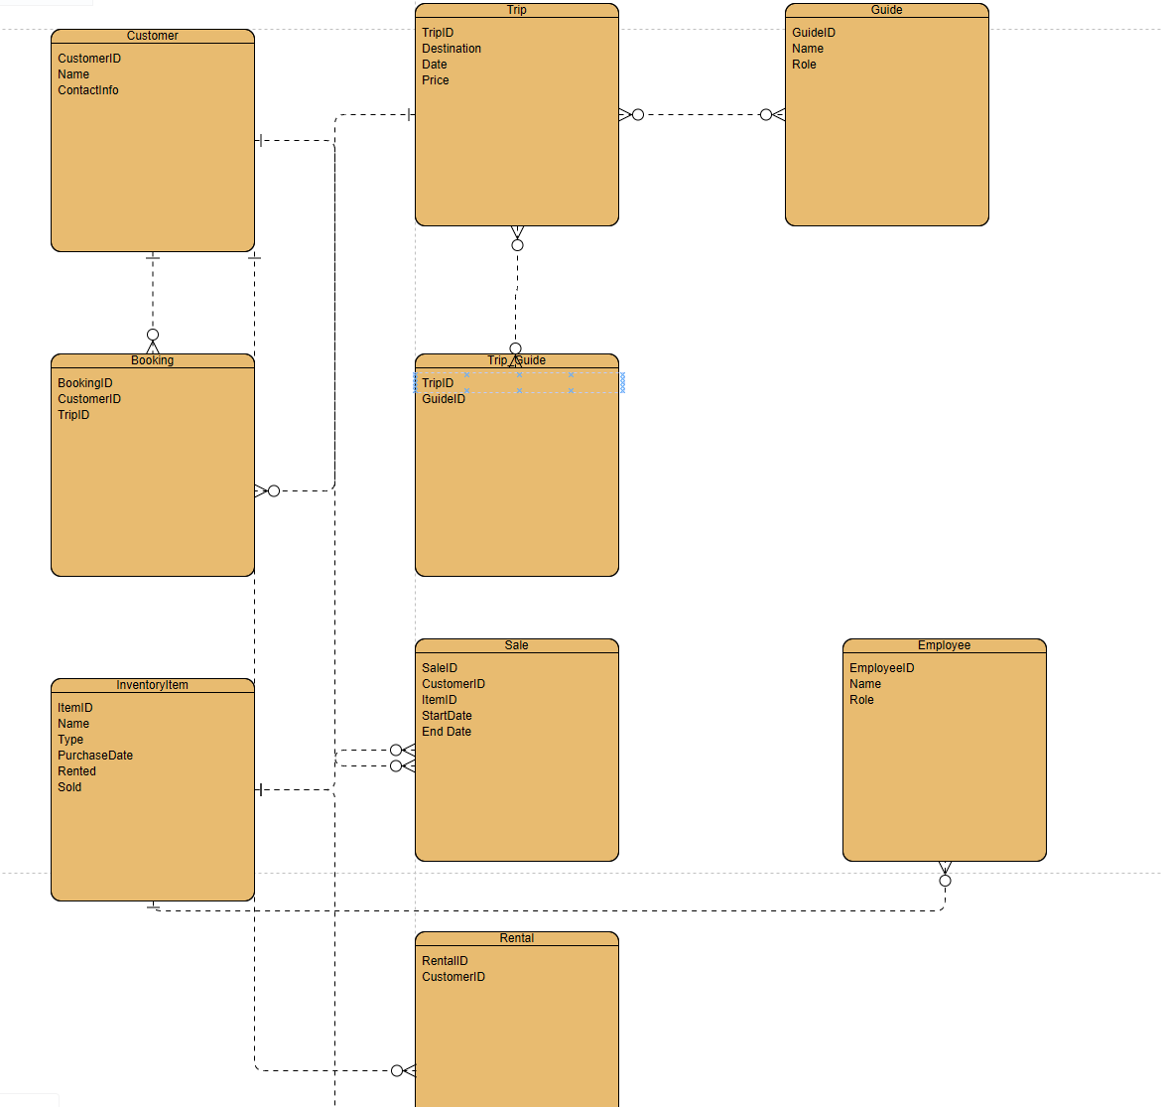  
Python Script:

from sqlalchemy import create_engine, Column, Integer, String, ForeignKey, Date, Boolean  
from sqlalchemy.ext.declarative import declarative_base  
from sqlalchemy.orm import relationship, sessionmaker

Base = declarative_base()

class Customer(Base):  
 __tablename__ = 'customer'  
 CustomerID = Column(Integer, primary_key=True)  
 Name = Column(String)  
 ContactInfo = Column(String)

class Booking(Base):  
 __tablename__ = 'booking'  
 BookingID = Column(Integer, primary_key=True)  
 CustomerID = Column(Integer, ForeignKey('customer.CustomerID'))  
 customer = relationship("Customer")

class Trip(Base):  
 __tablename__ = 'trip'  
 TripID = Column(Integer, primary_key=True)  
 Destination = Column(String)  
 Date = Column(Date)  
 Price = Column(Integer)

class Guide(Base):  
 __tablename__ = 'guide'  
 GuideID = Column(Integer, primary_key=True)  
 Name = Column(String)  
 Role = Column(String)

class TripGuide(Base):  
 __tablename__ = 'trip_guide'  
 TripID = Column(Integer, ForeignKey('trip.TripID'), primary_key=True)  
 GuideID = Column(Integer, ForeignKey('guide.GuideID'), primary_key=True)  
 trip = relationship("Trip")  
 guide = relationship("Guide")

class Sale(Base):  
 __tablename__ = 'sale'  
 SaleID = Column(Integer, primary_key=True)  
 CustomerID = Column(Integer, ForeignKey('customer.CustomerID'))  
 TripID = Column(Integer, ForeignKey('trip.TripID'))  
 StartDate = Column(Date)  
 EndDate = Column(Date)  
 customer = relationship("Customer")  
 trip = relationship("Trip")

class Employee(Base):  
 __tablename__ = 'employee'  
 EmployeeID = Column(Integer, primary_key=True)  
 Name = Column(String)  
 Role = Column(String)

class Rental(Base):  
 __tablename__ = 'rental'  
 RentalID = Column(Integer, primary_key=True)  
 CustomerID = Column(Integer, ForeignKey('customer.CustomerID'))  
 customer = relationship("Customer")

class InventoryItem(Base):  
 __tablename__ = 'inventory_item'  
 ItemID = Column(Integer, primary_key=True)  
 Name = Column(String)  
 PurchaseDate = Column(Date)  
 Refurbished = Column(Boolean)  
 Sold = Column(Boolean)

# Create an engine that stores data in the local directory's database file.  
engine = create_engine('sqlite:///erd.db')

# Create all tables in the engine.  
Base.metadata.create_all(engine)

# Create a configured "Session" class  
Session = sessionmaker(bind=engine)

# Create a session  
session = Session()

print("Database and tables created successfully.")